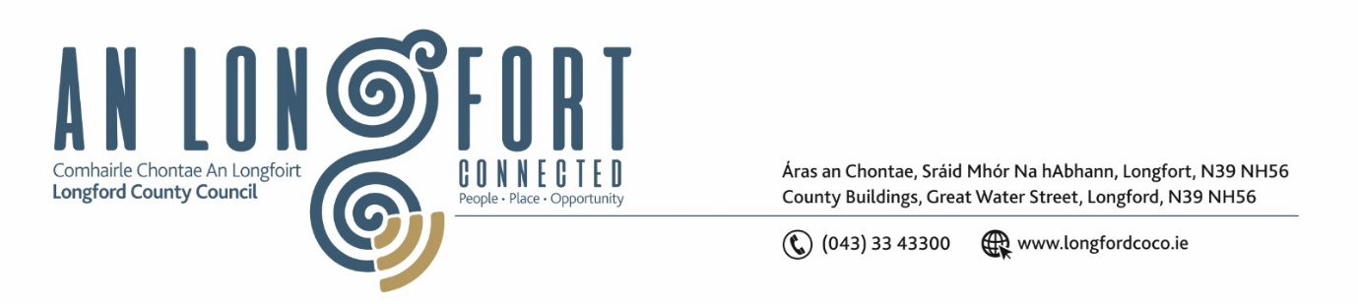

**LONGFORD MUNICIPAL DISTRICT**

**Minutes of Meeting of Longford Municipal District held in the Council Chamber Aras an Chontae and via MS Teams on Wednesday, 23 November 2022 at 3.30pm**

**CATHAOIRLEACH**: Councillor Seamus Butler

**MEMBERS PRESENT**: Councillors – Martin Monaghan, Uruemu Adejinmi, John Browne, and Gerry Warnock

**IN ATTENDANCE**: Mr. John Brannigan, Director of Services

Mr. Eamonn Bennett, Senior Executive Engineer

Ms. Lorraine Mc Kee, Administrative Officer

Mr. Richard Smith, Senior Executive Architect

**MEETINGS**

**ADMINISTRATOR:**  Ms. Ann Marie Mc Keon

**APOLOGIES:**  Councillors - Gerry Hagan, Peggy Nolan

**ADOPTION OF MINUTES – circulated**

On the proposal of Councillor John Browne seconded by Councillor Gerry Warnock it was unanimously agreed to adopt Committee Minutes of Meeting of Longford Municipal District Committee Meeting held on the 26 October 2022.

On the proposal of Councillor Gerry Warnock seconded by Councillor Uruemu Adejinmi, it was unanimously agreed to adopt Minutes of the Longford Municipal District Meeting held on the 26 October 2022.

**MATTERS ARISING FROM MINUTES**

None.

**DECLARATION OF INTEREST BY MEMBERS**

None.

**MANAGEMENT REPORT**

The Management Report, as circulated, was noted.

Senior Executive Engineer, Eamonn Bennett responded to questions on the following:

* Christmas Lights
* Works at Tesco/Market Square/Ballinalee road
* Shroid
* Chewing gum
* Battery road

The members unanimously agreed that the Taxi rank should be moved back up to the square as soon as possible.

**CONSIDERATION OF PART VIII NO. 101 -** **Shared Pedestrian/Cyclist Bridge over River Camlin with connecting pedestrian and cycleway provision either side of existing service road at Abbeycartron/Templemichael, Longford Town, Longford. Report in accordance with Section 179 of the Planning and Development Act 2000 (as amended) and Part 8 of the Planning & Development Regulations 2001 (as amended) – as circulated.**

On the proposal of Councillor Uruemu Adejinmi, seconded by Councillor Martin Monaghan the members unanimously agreed to adopt the Part VIII Number 101 Shared Pedestrian/Cyclist Bridge over River Camlin with connecting pedestrian and cycleway provision either side of existing service road at Abbeycartron/Templemichael as per report circulated.

**CONSIDERATION OF PART VIII NO. 97 -** **Construction of Storage Room, changes to layout of first floor and works to the changing rooms to the Leisure Centre, Albert Reynolds Peace Park, Longford. Report in accordance with Section 179 of the Planning and Development Act 2000 (as amended) and Part 8 of the Planning & Development Regulations 2001 (as amended) – as circulated.**

On the proposal of Councillor Gerry Warnock, seconded by Councillor Seamus Butler the members unanimously agreed to adopt the Part VIII Number 97 Construction of Storage Room, changes to layout of first floor and works to the changing rooms to the Leisure Centre, Albert Reynolds Peace Park, Longford as per report circulated.

**CONSIDERATION OF PART VIII NO. 100 -** **Proposed Skatepark with Royal Canal Greenway connection at the Old Greyhound Track, Townparks, Longford. Report in accordance with Section 179 of the Planning and Development Act 2000 (as amended) and Part 8 of the Planning & Development Regulations 2001 (as amended) – as circulated.**

On the proposal of Councillor Uruemu Adejinmi, seconded by Councillor Gerry Warnock the members unanimously agreed to adopt the Part VIII Number 100 Proposed Skatepark with Royal Canal Greenway connection at the Old Greyhound Track, Townparks, Longford as per report circulated.

**NOTICES OF MOTIONS, SUBMITTED BY COUNCILLORS:**

**Storm drains in Longford Town area**

As per Standing Order 20 Councillor Peggy Nolan in her absence requested that Councillor John Browne move this motion on her behalf.

The following Notice of Motion was proposed by Councillor John Browne and seconded by Councillor Gerry Warnock -

I am requesting Longford County Council to carry out an extensive review of all storm drains in the Longford Town area. The situation on Convent Road needs immediate attention as the effect of climate change is impacting on the height of the surface water and this in turn is impacting on pedestrians.

**Response**

Longford County Council agreed to review the condition of storm drains in the Longford Town area. The areas of Convent Road and College Park were outlined as areas with specific drainage issues.

This concluded the business of the meeting.

**Signed: ____________________**

**Ann Marie Mc Keon,**

**Meetings Administrator.**

**Confirmed and adopted at Longford Municipal District Meeting held on the 25 January 2023.**

**Signed: _______________**

**Cathaoirleach.**